6.74: a) 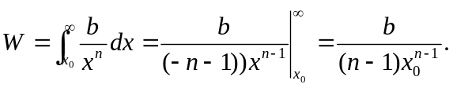
Note that for this part, for 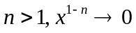 as . b) When 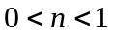, the improper integral must be used,

and because the exponent on the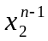 is positive, the limit does not exist, and the integral diverges. This is interpreted as the force F doing an infinite amount of work, even though 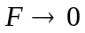 as 